

**Cairo University**

**Faculty of Computers & Artificial Intelligence**

**Operations Research & Decision Support Dept.**

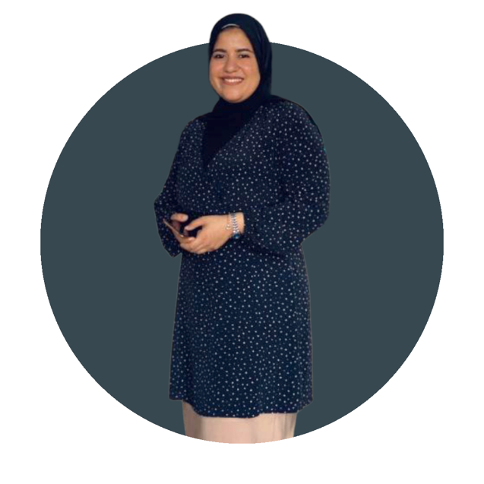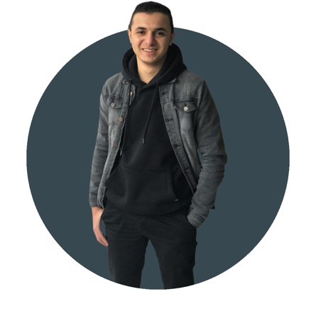

Mohamed Rizk M Mohamed Eslam

Sara Adel

| Project Title | Retail Sales Forecasting |
| --- | --- |
| Submitted by | 1. Name: Sara Adel Basha   ID: 20190232  E-mail: sara2019232@gmail.com  Phone: 01140790367   1. Name: Mohamed Rezk Abdelftah   ID: 20190439  E-mail: [mlashin524@gmail.com](mailto:mlashin524@gmail.com)  Phone:01002728873   1. Name: Mohamed Eslam Amin   ID: 20190419  E-mail: [20190419@stud.fci-cu.edu.eg](mailto:20190419@stud.fci-cu.edu.eg)  Phone: 01280024800 |
| Project Supervisor: | DR. DOAA SALEH  ALI |